BLA Lite For Mac/Windows
Instructions for Remote Windows/Office 365 Use (Windows and Mac):

Step 1: Go to an Internet browser (Google Chrome, Safari, ect.)

Step 2: Copy and Paste this link and click enter:
https://rdweb.wvd.microsoft.com/arm/webclient/index.html
You should see this screen once you do so: 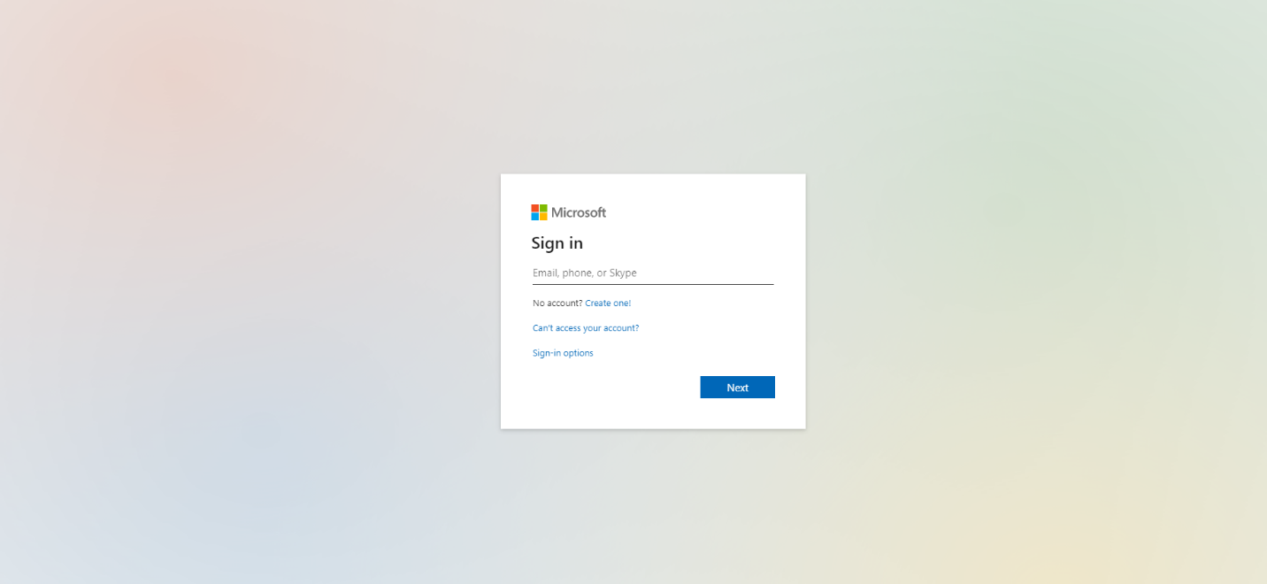
You will need to enter in your mybama email (ex. mybamausername@crimson.ua.edu)

After you enter in your email, it will prompt you to enter in your mybama password, as shown below:
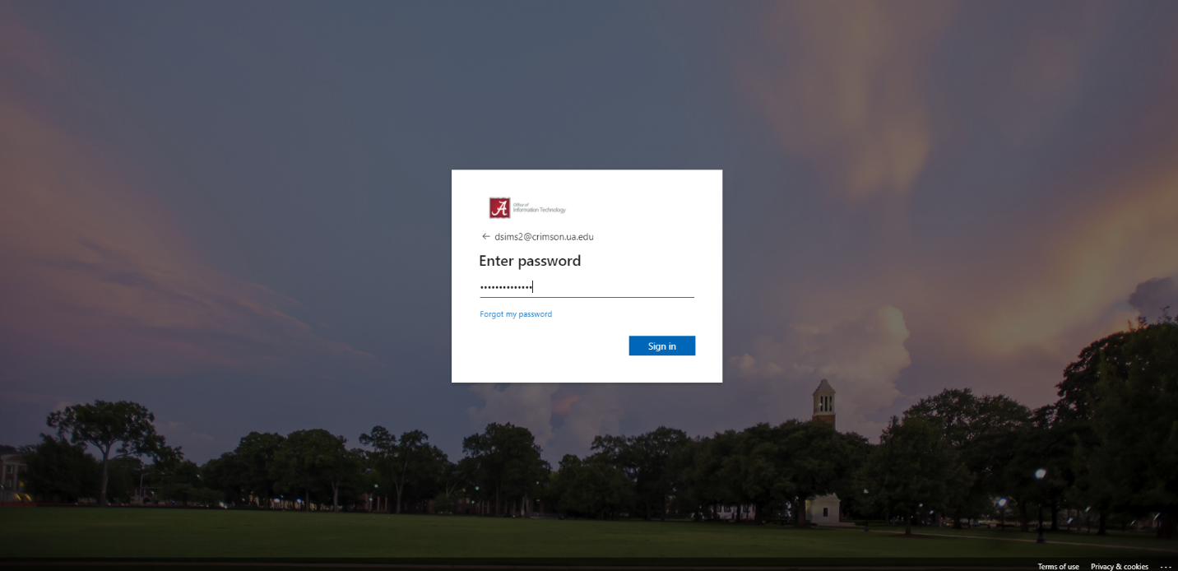
*****You will need to make sure you have DUO Mobile set up on your smartphone because you will get a notification after you enter in your password.

Step 3: Once that is completed you should see this screen:

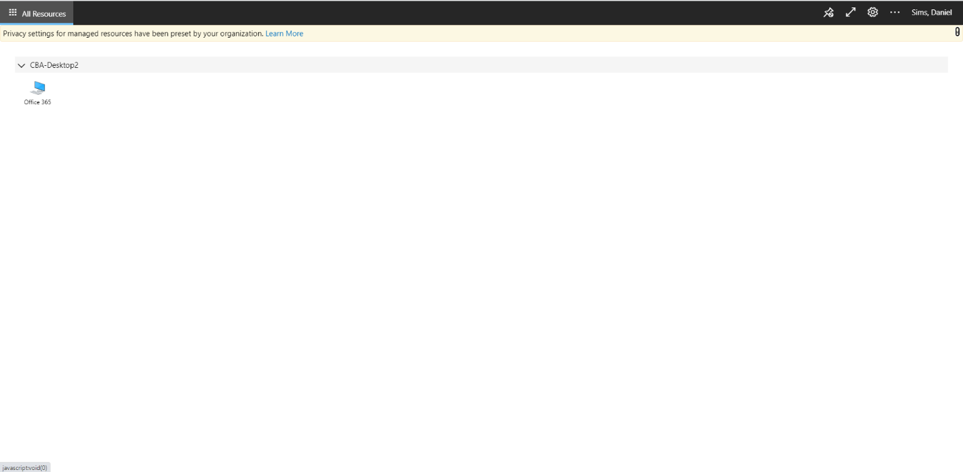
Click on the Office 365 icon, and keep the default settings, then click “Allow”

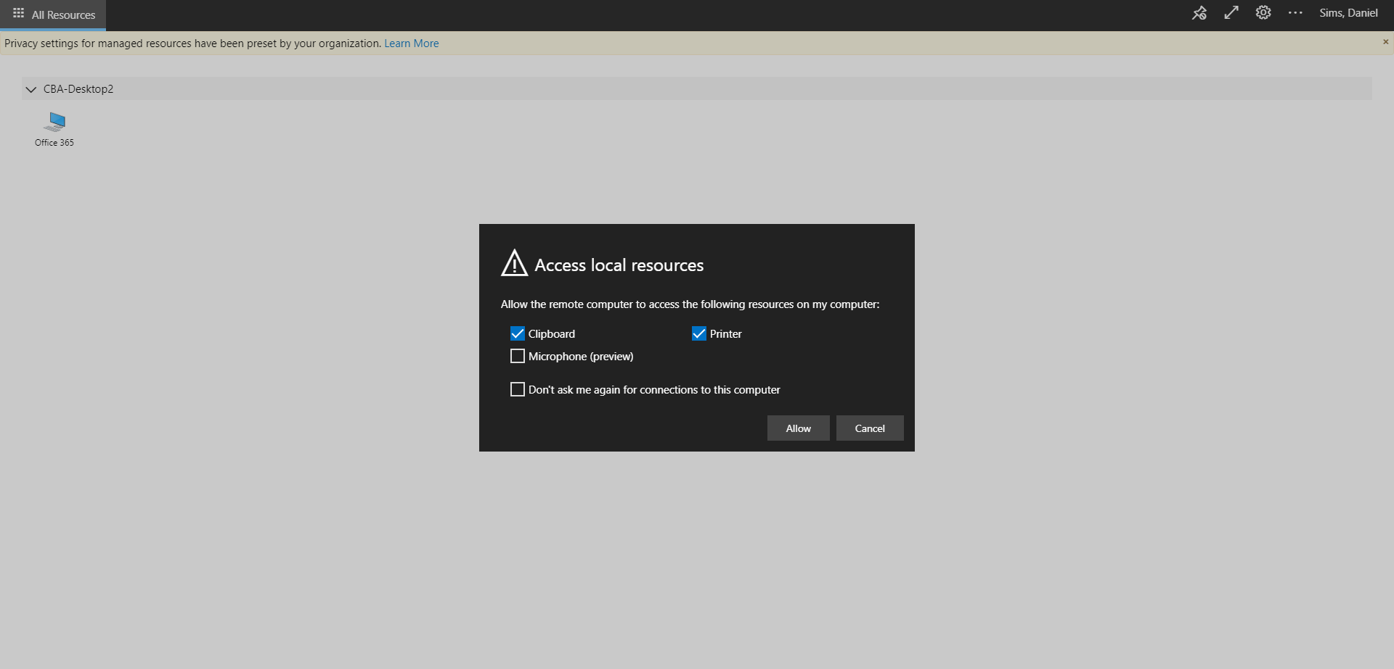

Step 4: Once step 3 is complete; you will see this screen:

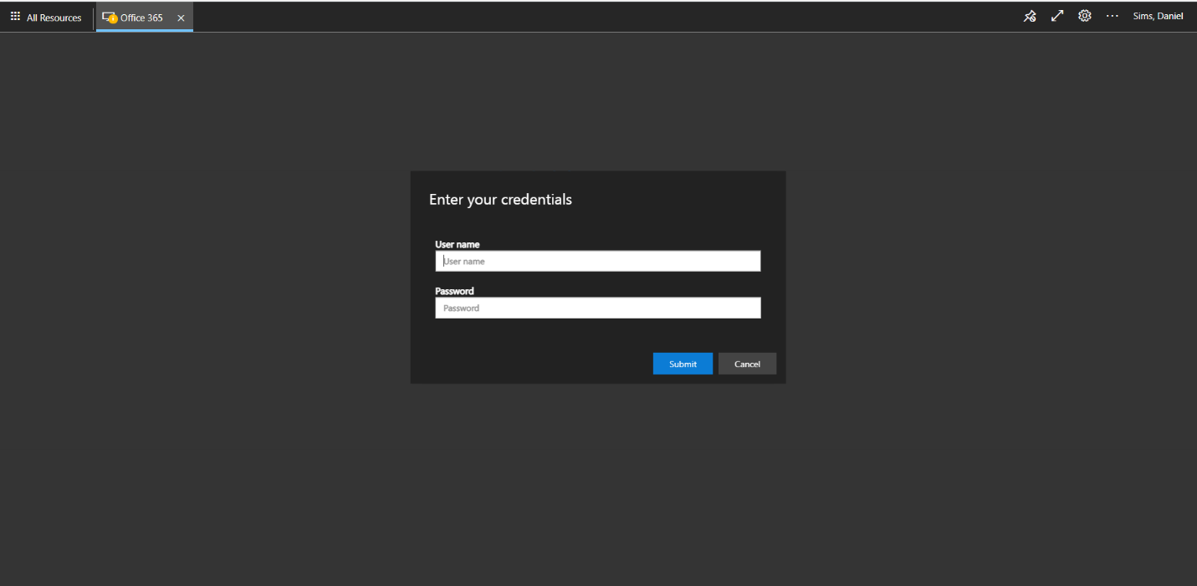
Enter in your mybama username and password again (this time without the @crimson.ua.edu attached to it)

Step 5: Once step 4 is complete; you will see it log in like this:

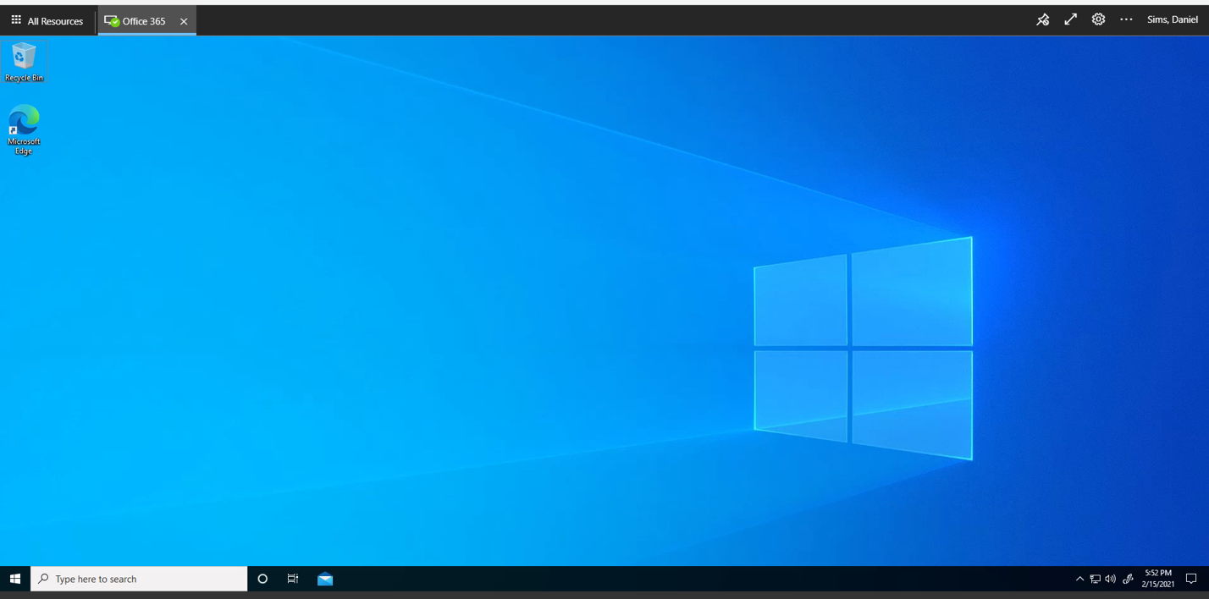

If you have files that you want to utilize from another computer, email them to yourself and then you can access your email through the internet after following these instructions.

